## Study Tour Report – Cosmic Ray Laboratory (Ooty)

### 1. Centre

The **Cosmic Ray Laboratory** at Ooty, established by TIFR, is one of the most powerful global radio telescopes monitoring cosmic rays. Conceived by Dr. Homi J. Bhabha in 1945 as an independent facility, it carries forward the vision of Indian pioneers like Sir C.V. Raman, Dr. Homi J. Bhabha, and Dr. Vikram Sarabhai. The centre plays a vital role in the real-time study and monitoring of cosmic rays, which are high-energy radiations originating outside our solar system.

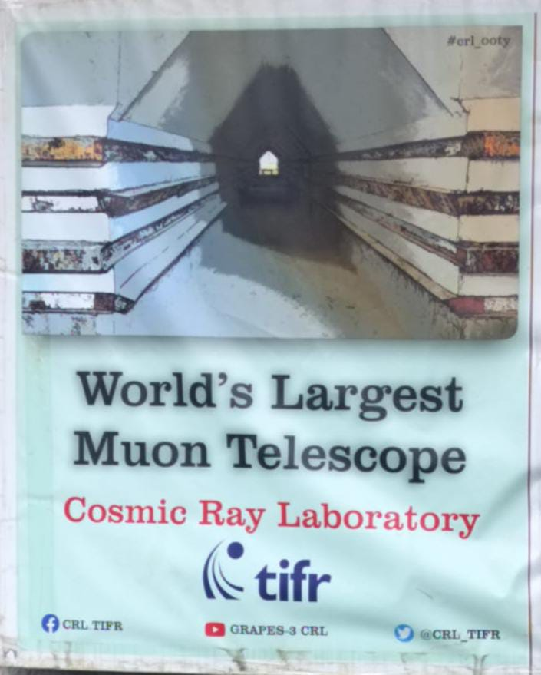 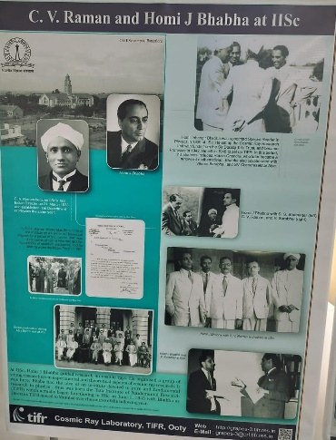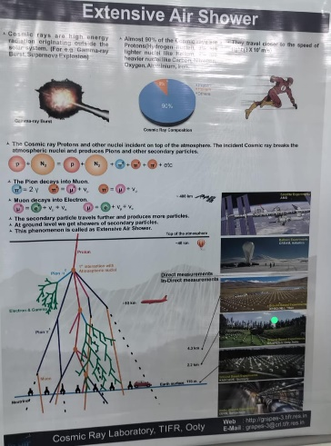

### 2. Facility

The laboratory has over **4000 glass detectors** that capture gamma rays and analyze cosmic ray signals from primary and secondary sources. It also hosts the **world’s largest Muon Telescope**, making it a unique facility for space science research. About 40 employees work here, creating their own hardware and software for research, running on Linux systems with specialized applications like **ROOT** for advanced data analysis.

### 3. What Students and Teachers Could Do

Students can learn how cosmic rays and gamma rays are detected, monitored, and studied using large-scale instruments. They also gain exposure to real research software, data analysis methods, and advanced computing tools. Teachers can link these experiences with physics, space technology, and scientific history, inspiring students to pursue careers in space and research.

By **Arshsd Pasha**

Date: 30/08/2025

College: Seshadripuram Degree College ,Mysore